1st Syed Saifulla H 2nd DR. Srabana Pramanik
Dept. of SOCSE Dept. of SOCSE
Presidency University Professor
Bangalore, India. Presidency University
Saifulla.saif@icloud.com Bangalore, India.
srabana.pramanik@presidencyuniversity.in

Abstract— Every company wants to modify its environment to suit the cloud computing approach so that it can become more productive and cost-effective. Organizations who opt for cloud technology are facing problems when it comes to enterprise mobility management tools. There are certain difficulties involved in managing devices due to the complexity of Microsoft environment. But there is one software from Microsoft called Microsoft Intune that is meant to solve these kinds of issues by providing solutions for device management along with enhancing security features. With the use of this product, an organization can prevent any kind of security breach that can occur either inside the organization itself or even while dealing with other companies. This paper will provide a methodical analysis of the performance of Microsoft Intune as far as device management and security are concerned.

Keywords: Microsoft Intune Secure Restrict the Mobiles In work Profile

I. INTRODUCTION
User device security is one more under-researched area in the field of Cloud Security. Technically speaking, users should be prepared to change anything inside the company whenever it occurs. However, the previously changed thing has to give a good user experience and be not too complicated. For example, imagine that you need to type a BitLocker key, scan a fingerprint and recognize your face to enter the device, also providing a password. From the technical standpoint, it is a very good measure that will protect corporate information and devices from unauthorized access. Nevertheless, the problem of users who are going to find it difficult to remember the key and a powerful password appears here.

Nowadays many companies use cloud services together with numerous devices. As a result, a number of issues arise for the IT security team. Therefore, companies require a solution that would help them to overcome these obstacles. Microsoft Intune is a powerful cloud-based EMM platform with a wide range of useful tools that can be used by organizations. However, their efficiency has to be evaluated systematically.

II. Literature Review

This topic was investigated more than ten years ago by Gustavo et al. [1], whose researchers suggested a novel security architecture for the mobile enterprise based on networked security and cloud computing. Research in mobile device management was also carried out by Song, X., & Yang, C.-H. [2]. They utilized the Android Open Source Project and SELinux to assist enterprises in managing and securing not only corporate but also BYOD mobile devices. This solution provides various ways to track locations, authenticate files, provide real-time permission management, and deliver informative push notifications. It was implemented using the Java programming language and tested in a customized Android 7.1.1 device. 12 Assessing the Efficiency of Using Microsoft Intune in Protecting Devices: The Need to Balance Security Properties and User Experience in an Enterprise Environment Baltazar et al. [3] investigated the issue and emphasized the significance of Enterprise Information Systems (EIS) as a possible catalyst for mobility improvement and sustainability. The study was carried out using a case study approach at one of the Portuguese firms for the carsharing platform.

The authors also acknowledged the importance of AI/ML for the purposes of security. Hasan et al. [4] described a framework along with guidelines for protecting mobile enterprise applications. In particular, the proposed framework consists of a meta-model (UML diagram), which contains information about the components of the framework; guidance model, containing threats and countermeasures to mobile security and security design decision making for logging purposes. In this case, the difficulty associated with the proposed framework is in the new emerging threats and countermeasures, as well as zero day attacks. Nevertheless, the framework can help enterprises in decision-making regarding mobile apps. Regarding BYOD devices, there was an article by Hina Batool [5], who speaks about MDM systems.

Some of the important characteristics of the MDM have been profile management, location tracking, lock and wipe remotely, malware protection, data backups and encryption, and URL blacklisting. The researcher studied various MDM solutions like AirWatch provided by VMware, IBM MaaS360, and Kaspersky Lab. A comparison table was created for these solutions with Yes/No answers regarding security requirements. Almost all of the security requirements have been fulfilled or partially fulfilled by vendors in their solutions. This particular research does not talk about the effectiveness of MDM from security perspective either. Another research related to the importance of having strategy developed can be seen in Yucel [6] paper. Here researcher used characterizing of mobile strategy using many variables like goals of strategy, user base, mobile technology, platform considerations, strengths, weaknesses, risk mitigation, and many other parameters. Generic model calculates the percentage of potential users and interrelationships among factors including user adoption, benefits, economic utility, and many more.

The motivation behind the chosen topic was growing ROI while getting benefits of enterprise mobility. Other area to examine is MAM (mobile application management), which is used to push applications via a centralized console.

The MAM topic was investigated by Yamin, M. M., & Katt, B [7]. There is the introduction of MDM and its basic functionalities; enabling protocols of MDM (Smart Message, Open Mobile Alliance Device Management, Over-The-Air Programming). In other papers [8], [9] there are MAM questions and problems examined. Also, Ana Maria Suduca and Mihai Bizoia [10] investigated ways to integrate and push applications in the easiest way possible. Microsoft Intune was used for this purpose and helped to greatly reduce application pushing effort. As a result, the team was able to push the videoconferencing application Zoom via Intune. Most of the examined articles use the same approach – comparison. It is no longer enough to compare features to create a secure solution in the modern world. That is why the author of the article suggests a testing scenario that can provide some solutions for Security Operation teams.

III. Background
Microsoft Intune is the cloud-based service offered by Microsoft as the EMM and MDM product. Microsoft Intune offers support for various platforms: Windows, macOS, Android, Linux, and iOS devices. The onboarding process for devices into Microsoft Intune can be done in several ways: group-based, Autopilot, Apple Business Manager for iOS devices, and Android Enterprise for Android devices. Furthermore, the onboarding process for users can be done automatically when logging in with Windows credentials for the first time or using the Company Portal app downloaded from the store. After successful completion of the onboarding process, users will be subjected to various policies that were predefined in Microsoft Security Center and can be enforced during subsequent updates. The architectural design of Microsoft Intune is shown in the following diagram.

- System Architectural Diagram

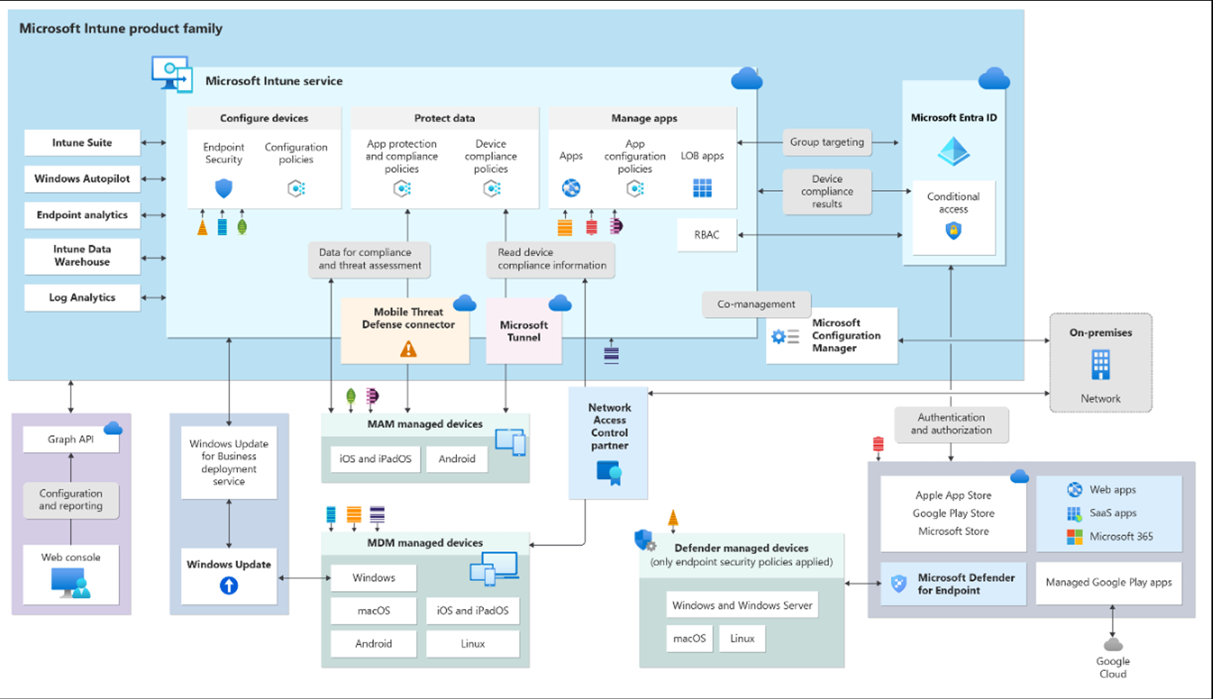
High-level Microsoft Intune architecture
As indicated in Figure 1 below, the architecture comprises a number of elements including: the Microsoft Intune service, Graph API, Windows Update for Business deployment service, MAM managed devices, NAC partner, and Microsoft Configuration Manager for on-premises deployment. Additionally, the diagram illustrates the link between the Microsoft Intune service and Microsoft Defender for Endpoint, which is a robust security software that acts as an antivirus as well as an endpoint detection and response software.
IV. PROPOSED METHODOLOGY
For analyzing the efficiency of Microsoft Intune, a structured approach of methodology is needed. The methodology contains different stages that will help determine the effectiveness of security and its influence on the user experience.
- Criteria for Evaluation
At the first stage, there is a need to identify criteria for evaluating the performance of Microsoft Intune. In this case, it includes the following aspects:
- Compliance of devices with security
requirements;
- Detection and prevention of malware;
- Effectiveness of remote wipe and the time spent;
- Timing of deployment of security patches;
- Timing of updating policies;
- Effectiveness of app protection policies.
- Data Gathering Strategy
Data is critical for preventing attacks. It means that such information as the IP address and agent status of an endpoint can be viewed as data. In this case, the data sources are as follows:
- Laboratory tests with isolated networks;
- Test in production environments in different organizations;
- Surveys of users about their experiences;
- Logs and compliance reports.

C. Comparative Analysis Approach

Microsoft Intune provides numerous features regarding configuration, policies, and integration options. In light of that, best practices will be applied to establish a safe environment within the organization. The comparative analysis includes:
- Diverse security feature implementations
- Several policy setups
- Variety of organizations with different needs
- Diverse user experiences based on varying security levels

- Technical Criteria Assessment

From the technical standpoint, the proposed solution should possess:

- Scale: Capability to support a growing number of devices
- Adaptability: Flexibility in accommodating user needs
- User-friendliness: Ease of use by end users
- Manageability: Ease of management for security professionals

Regulatory Compliance:

Regulatory compliance ensures that all data is processed and stored in accordance with relevant laws and regulations. There are global regulations such as the General Data Protection Regulation in Europe and Health Insurance Portability and Accountability Act in US healthcare sector. In addition, there are specific industry regulations. Having a compliance method enables one to pass an audit promptly.

E. Compliance and Regulatory Issues

Compliance guarantees that data management is in accordance with legal standards and best practices. In addition to international standards such as GDPR within Europe and HIPAA within the United States, there are specific standards for different industries. Having systems of compliance and regulation can help in auditing processes more rapidly.

- Metrics for Assessment

Metrics have been applied in this research to assess the general security posture and user experience level. The following table shows the information regarding metrics. The following metrics have been assessed according to the security characteristics where:
2: Security characteristic greatly influences user experience
1: Security characteristic influences user experience
0: Security characteristic does not influence user experience

1: Evaluation Parameters

Table 1: Evaluation Parameters
Security Features |  | User Experience Factors
Device encryption |  | Ease of enrollment
Multi-factor authentication |  | App accessibility
App protection policies |  | Performance impact
Conditional access |  | Privacy considerations
Data loss prevention |  | Self-service capabilities
Remote wipe capabilities |  | User interface intuitiveness
Compliance policies | Support and troubleshooting experience

V. EXISTING SYSTEMS AND THEIR LIMITATIONS
A. Traditional MDM Solutions

Many traditional MDM solutions exist on the market for more than a decade. The list of common weaknesses that apply to all of them includes the following:
- Air Watch by VMware
- Pros: Advanced functionality, successful integration
- Causes of Weaknesses: Complexity of deployment process, high expenses, complexity of interface

- IBM MaaS360

- Pros: In-depth analysis of data, advanced artificial intelligence capabilities
- Causes of Weaknesses: Insufficient personalization of solution, slow operation of application at scale

- Kaspersky Lab MDM
- Pros: Focus on cybersecurity, efficient detection of malicious code
- Causes of Weaknesses: Low compatibility of solution, low integration capabilities

- Limitations of Existing Research

While the literature focuses on the comparative evaluation of different MDM tools in terms of features, the following problems can be detected:

- Feature-based Evaluation: The literature does not make any comparisons of efficiency between solutions.
- Lack of User Experience Assessment: Losses in efficiency due to security concerns are not considered.
- Lack of Implementation: Testing is done under lab conditions only.
- Statistical Paradox: Trade-offs in efficiency are not assessed quantitatively.
- Business Case-Specificity: Results cannot be generalized.

- Research Gaps in Current Literature

- The effect of security on user experience related variables.
- Statistical analysis of correlation between security utilization and user satisfaction.
- Different effects faced by companies depending on their type.
- Optimal settings for balancing usability and security needs.

VI. SYSTEM WORKFLOW

- High-Level Architecture

The flowchart of the system implementation workflow for Microsoft Intune includes several stages starting from the initial device registration to the ongoing process of maintaining security. The system architecture comprises multiple elements including:

Microsoft Intune Service, Graph API, Windows Update for Business Deployment Service, MAM Managed Devices, Network Access Control Partner, and Microsoft Configuration Manager for on-premises deployments. Additionally, Microsoft Intune is compatible with Microsoft Defender for Endpoint, which is a multifunctional tool that acts as antivirus software and endpoint detection and response platform simultaneously.

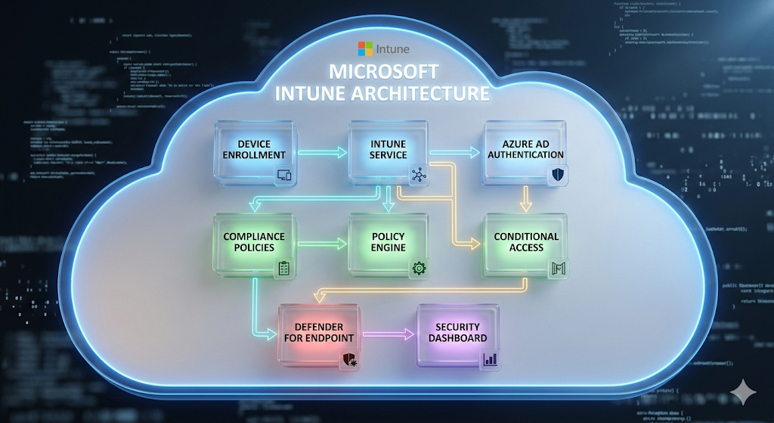

Fig. 1: High-level Microsoft Intune Architecture

- Device Enrollment Workflow

The device registration starts once the user signs in using his/her corporate account. The Company Portal app supports this enrollment process; then, Intune enrolls the device and does its first compliance check. Once all the compliance criteria have been met, policies will be enforced, and the device will get access to corporate resources. Otherwise, the user will have to remediate.

- Policy Enforcement Workflow

Enforcement is carried out in a constant loop whereby user attempts for access prompt the policy engine to evaluate conditions. This evaluation includes checking device compliance and user risk levels, among other criteria that will help decide what the next step will be. The policy enforcement decision tree flows like this: if the device complies and multifactor authentication passes, then the user gets access. However, if the device doesn't comply, then access is denied or remediation is needed.

- Security Incident Response Workflow

Upon detection of any security threat through the use of Microsoft Defender for Endpoint, an alert is triggered and directed to Intune where the response process takes place. The automated response process involves such tasks as isolating the affected endpoint device, enforcing a password reset, wiping the device remotely if necessary, denying access to resources, and contacting the security team.

VII . SYSTEM IMPLEMENTATION

This implementation was done in a test environment where the network could be isolated. For the data collection, data were obtained from different kinds of organizations, including financial institutions, accommodation providers, hotels, and resorts.

A. Device Encryption Implementation

BitLocker allows for complete device encryption for the Windows OS. It is possible to generate policies using Microsoft Intune to use BitLocker in all devices. To encrypt the device, one needs to configure a profile in Intune. This can be configured in a silent manner, thus improving the user experience. The encryption will take place in the background, but users will be notified if any action is needed.

Multi-Factor Authentication Implementation

The influence of MFA has been huge in the current day and age. It prevents about 80% of the attacks. According to research done by Liu et al. [11], it has been demonstrated how MFA can be used not just in enterprises but even in IoT. As much as it prevents user credential theft, it introduces an extra step in signing into the systems. There are different methods through which one can achieve MFA, such as using notifications, SMS, voice, or even an authenticator code.

App Protection Policies Implementation

App Protection Policies (APP) are guidelines to ensure that all data stays secured or is restricted within the managed app. The policies ensure that corporate data is safe from any risk at the app level. For example, users can be asked for a PIN to access their work app, they have limited app-sharing options, and they are unable to save data in personal storage. This will decrease user experience since they will need one extra step to access the data of their organizations. The policies are set for Office apps, Edge browser, and Intune supported third-party apps.

Conditional Access Implementation

Conditional access is another policy that is implemented in organizations. It functions according to an if-then statement: if the conditions are fulfilled, then the user gets access; otherwise, access is denied or controlled. Microsoft Intune has a device state feature that depends upon the compliance status and may be compliant, non-compliant, and grace. Thus, using this feature, one can restrict access to top-end applications only after marking their devices as compliant through the Intune portal. There are different types of policies for office access, remote access, and risky access.

Data Loss Prevention Implementation

In cases where profile isolation takes place on the mobile devices, Intune allows using data loss prevention features. For instance, by the help of mobile application management policies, it becomes impossible for a user to transfer data from work profile to personal profiles. Redirection to corporate internal resources during search actions in the web browser Microsoft Edge is also possible. Data loss prevention includes configuration of app configuration policies for managed applications, limitation of data transferring between work and personal profiles, as well as encryption of all corporate data.

Remote Wipe Implementation

Wipe function might become crucial in many cases such as termination of employment or theft of a mobile device. According to the tests done in the lab, wiping will happen within a minute in case of Android smartphones and nearly instantly in case of iOS-based devices. There may also be various scenarios under which wiping will occur. These scenarios may include when an organization purchases corporate devices that are used by employees but now have to be reassigned to other departments. Alternatively, a company may need to decommision the device that was being used by another employee previously or allow contractors to access only selected corporate applications.

Compliance Policies Implementation

Every organization follows a set of local policies and procedures. The users need to follow the policies and procedures that have been defined earlier. The implementation process includes policies that comply with various platforms including Windows, macOS, iOS, and Android. The policies verify whether the devices are encrypted or jailbroken, minimum operating system version, passwords, and threat level on Microsoft Defender for Endpoint.

VIII. RESULTS AND ANALYSIS

All the mentioned characteristics were taken into account during the investigation. Having been tested on 650 devices in various companies, statistical analysis was conducted. The assessment based solely on the features is not sufficient, but wherever there are common points between security features and user experience, statistical analysis may be conducted.

A. Survey Methodology

This analysis includes all the mentioned security features and user experience characteristics. In order to collect data, a survey was conducted among the users of various organizations. On the basis of their responses and the results of the test conducted in the laboratory

B. Statistical Analysis

In this way, it is possible to analyze the pros and cons associated with the implementation of security features from the point of view of their effect on user experience.
In this case, we use the mean, median, and standard deviation for each of the security features. Since there are quite a few coefficients equal to 7 and one can simply pick up a median without considering an average of two midpoints, the median was used in order to calculate the standard deviation. The standard deviation will be helpful in calculating consistency with which each security feature influences different user experience aspects. Thus, the lower standard deviation, the more consistent the influence of the security feature. Here are the formulas that will be applied:

μ = (ΣX) / n

where:

μ = mean

X = each value in dataset

n = number of values

σ = √[Σ(x - μ)² / N]

where:

σ = standard deviation

μ = mean

x = each value in dataset

N = number of values

Table 3: Statistical Analysis of Survey Results
Security Feature | Mean | Median | Standard Deviation
Device Encryption | 0.57 | 1 | 0.53
Multi-Factor Authentication | 1.57 | 2 | 0.53
App Protection Policies | 0.71 | 1 | 0.49
Conditional Access | 1.14 | 1 | 0.69
Data Loss Prevention | 1.14 | 1 | 0.69
Remote Wipe | 1.14 | 2 | 1.07
Compliance Policies | 1.43 | 2 | 0.79

C. Analysis of Results

Statistical analysis of the findings shows some patterns about the effect of security measures on the user experience:

Device Encryption was shown to have the lowest mean impact (0.57). This could be due to the fact that it works in the background without needing any action from the user's end.

Multi-Factor Authentication had the highest mean impact (1.57). This measure would affect user experience as it involves an extra step during authentication.

Remote Wipe had the highest standard deviation (1.07). This means that its impact varies depending on the user experience factor. This is because there are various scenarios when remote wipe may happen.

App Protection Policy had the lowest standard deviation (0.49). It means that it has a consistent impact on the user experience factor. All apps impose similar restrictions on users.

IX. TECHNICAL IMPLEMENTATION

Microsoft Graph API Integration

This implementation utilizes Microsoft Graph API for programmatic management of Intune functionalities. With the help of such integration, one can implement fully automated management, policy application, and compliance assessment procedures. All Intune capabilities are available as a set of RESTful endpoints via Graph API.

Integration with Existing Systems

Integration of the solution with other software includes connections to:

Active Directory / Azure AD – user authentication

Microsoft Defender for Endpoint – threat detection

WinPak Attendance System – enforcement of policies according to physical presence of employees

SIEM systems – logging and alerts about violations

Performance Optimization

According to performance tests results, the time
needed for the application of the policies was less than 5 minutes for 95% of the devices. The system works fine with up to 10K devices without any significant delay due to optimization methods.

Security Considerations

In accordance with the concept of defense-in-depth,
security mechanisms applied here include:

The usage of TLS 1.2 encryption for all APIs

The renewal of certificates every 90 days

The usage of access tokens with max 60-min validity period

Logging all operations for auditing

Regular pen-testing

X. FUTURE WORK

However, there is room for exploration within this study regarding additional topics:

AI and Machine Learning Integration

It would be interesting to see how the AI/ML tools could be used for prediction and prevention of security events. Also, a comparison of the effectiveness of the security AI that is supposed to launch in the near future can help understand how it improves the existing system and reduces the occurrence of false-positive events.

Extended Platform Support

Further research on the support for additional platform could include:

Linux workstations in the process of their development

IoT and embedded systems

AR/VR devices to support training activities and collaboration

Wearable devices in healthcare, logistics, and manufacturing industries

Long-term User Experience Studies

Longitudinal analysis could help determine:

If the user adapts to the introduced security solutions and feels lesser pressure due to it after some period

The most optimal balance of security versus productivity among various user groups

How effective user training is at alleviating this issue

D. Cross-Platform Comparison

A research project could analyze Intune in relation to other Mobile Device Management (MDM) providers such as VMware Workspace ONE, Jamf Pro for Apple, IBM MaaS360 and Google Endpoint Management.

Zero Trust Architecture Integration

A research project could analyze how to implement Zero Trust principles by researching how Intune may aid the organization in their Zero Trust implementation maturity, how it interacts with existing technologies categorized as Zero Trust components, and creating metrics to assess the effectiveness of Zero Trust implementation.

Compliance Automation

This could be pursued in a research project by having a research team that will investigate real-time dashboards for compliance reporting that will automatically generate evidence for future audits and criteria illustrating compliance framework alignment with MDMs (for example, GDPR, HIPAA, ISO 27001).

XI. CONCLUSION

This research aimed to investigate the effectiveness of Microsoft Intune in terms of securing the organization's devices by analyzing trade-offs between security-related functionality and user experience of using these features. It was found that Intune includes a full range of security features such as device encryption, multi-factor authentication, app protection policies, conditional access, data loss prevention, remote wipe, and compliance policies. According to statistical calculations, while some features such as device encryption have virtually no influence on user experience (mean=0.57), others such as multi-factor authentication significantly influence usability (mean=1.57). Among all security features, the one demonstrating the highest variability of influence on the user experience was remote wipe (SD=1.07). At the same time, app protection policies had similar effects on all aspects of user experience.

The trade-off analysis framework developed during this research proves that Microsoft Intune can serve as an efficient device management solution. However, its implementation needs to be conducted taking into account various priorities. The trade-offs framework allows making evidence-based decisions that will lead to finding the right balance between required level of security and user experience and thus to creating an optimal security posture without sacrificing productivity.

XII. REFERENCES

[1] De los Reyes, G., Macwan, S., Chawla, D., & Serban, C. (2012). Securing the mobile enterprise with network-based security and cloud computing. 35th IEEE Sarnoff Symposium.

[2] Song, X., & Yang, C.-H. (2017). Mobile Device Management System Based on AOSP and SELinux. IEEE Second International Conference on Data Science in Cyberspace (DSC).

[3] Baltazar, S., Barreto, L., Amaral, A., & Pereira, T. (2020). Enterprise Information Systems (EIS) as a key driver towards improved mobility. 2020 IEEE International Conference on Engineering, Technology and Innovation (ICE/ITMC).

[4] Hasan, B., Dmitriyev, V., Gomez, J. M., & Kurzhofer, J. (2014). A framework along with guidelines for designing secure mobile enterprise applications.

[5] Batool, H., & Masood, A. (2020). Enterprise Mobile Device Management Requirements and Features. IEEE INFOCOM 2020 - IEEE Conference on Computer Communications Workshops (INFOCOM WKSHPS).

[6] Yucel, S. (2017). Evaluating Enterprise Mobility Strategy. 2017 International Conference on Computational Science and Computational Intelligence (CSCI).

[7] Yamin, M. M., & Katt, B. (2019). Mobile device management (MDM) technologies, issues and challenges. Proceedings of the 3rd International Conference on Cryptography, Security and Privacy (pp. 223-227).

[8] Medudula, M. K., Sagar, M., & Gandhi, R. P. (2016). Mobile Device: Applications, Over the Top Services, Identity Protection and BYOD Policy. In Telecom Management in Emerging Economies (pp. 207-227). Springer

[9] Raj Kumar Koneru, Pattabhi Rama Rao Dasari, Prajakt Deshpande, Vivek Iyer, Rajendra Komandur, Aravind Perumal, Sriram Ramanathan, Matthew Terry, Vamsi Krishna Vagvala, Sathyanarayana Vennapusala, et al. (2016). Mobile application management systems and methods thereof (U.S. Patent No. 9,405,723). U.S. Patent and Trademark Office.

[10] Suduca, A. M., & Bizoa, M. (2022). AI shapes the future of web conferencing platforms. 9th International Conference on Information Technology and Quantitative Management.

[11] Liu, W., Wang, X., & Peng, W. (2019). Secure Remote Multi-Factor Authentication Scheme Based on Chaotic Map Zero-knowledge proof for Crowdsourcing Internet of Things. IEEE Access, 7, 1-1.

